Save the date: 75 years VNS, Jubilee 2022
On July 29 2022 the Vereniging de Nederlandse Schapendoes celebrates its 75th birthday.
We will enjoy this memorable moment during our Anniversary Weekend from 19 till 21 Augustus 2022, at the KC Pampus in Almere, the Netherlands.
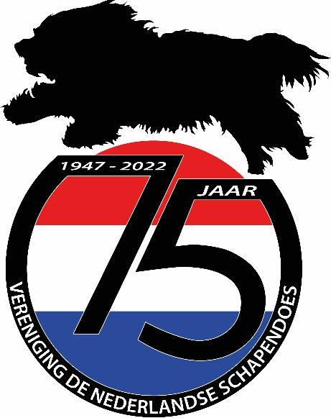

We would like to welcome all Schapendoes lovers to come and join our party. We have invited our members, all members of our international sister clubs and Schapendoes lovers in general to participate in the Young Dogs Day and the Championship Club Match that will be held during this weekend. It will be an excellent opportunity to meet large numbers of our beloved breed. Please save the dates in your agenda for 2022.
Preliminary agenda (subject to change):
- 19 August: arrival of the guests, official opening and party night.
- 20 August: Young Dogs Day (for all pups/litters born between 30-11-2020 en 29-11-2021) and (international) symposium. Focus will most likely be on DNA testing, Mean Kinship and Population Management.
- 21 August: Anniversary Championship Clubmatch.
It will be possible to camp in the direct area of the event location or stay in hotels nearby.
During the weekend we aim to organize a fun market with many shops and workshops.
Don’t miss this international Schapendoes event!

More details to follow in the upcoming year.

